AROGYAM 2023 – Celebrated Mental Health Day by H.M. Sr. Sec. School

AROGYAM 2023, our Mental Health Day celebration, was a holistic event designed to address various aspects of mental well-being. The event featured six distinct activities, each targeting different classes and topics.

Activity 1: Stress Management - Breathing Exercise in Morning Assembly (Week 1, Day 5)
Classes - VI to XII
It aimed to alleviate stress, boost focus, and enhance emotional regulation and promote mindfulness through controlled breathing. These exercises equip students with valuable tools to cope with academic and personal challenges, ultimately improving their overall well-being and performance.
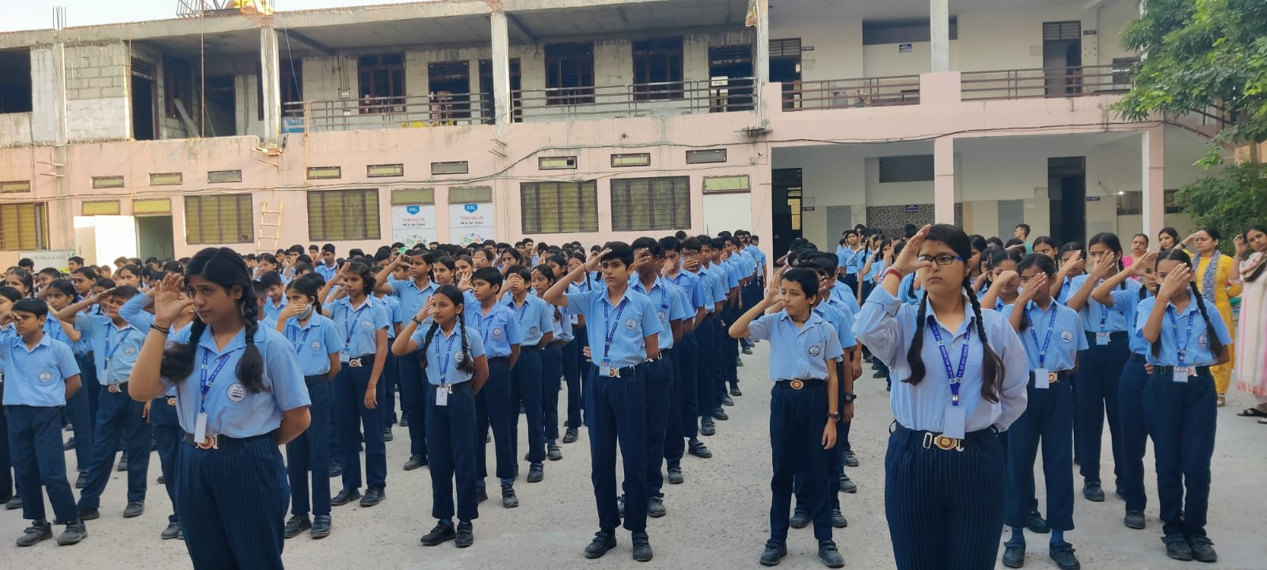

Activity 2: Parent Sensitization Program (Week 1, Day 7)
This informative session aimed to empower parents with knowledge and tools to keep their children safe and sensitize. Open communication between parents and the school is vital for addressing sensitive issues effectively.

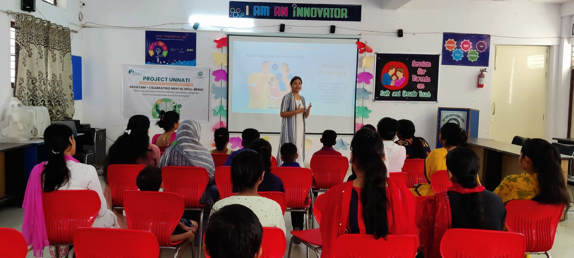
Activity 3: Safe and Unsafe Touch Activity (Week 2, Day 9)
Classes - III to V
The activity aimed to create awareness and educate students about safe and unsafe touch, with a special focus on child safety. This activity involved a discussion followed by the screening of the movie ‘Komal’ to impart this vital knowledge in a child-friendly and engaging manner. Movie screenings can be a powerful tool for initiating discussions on sensitive topics.
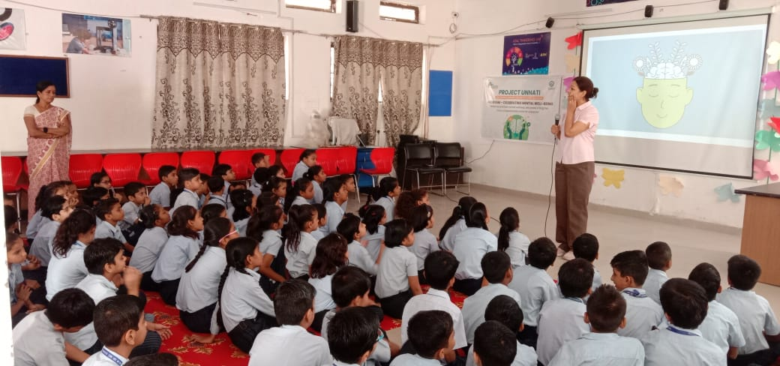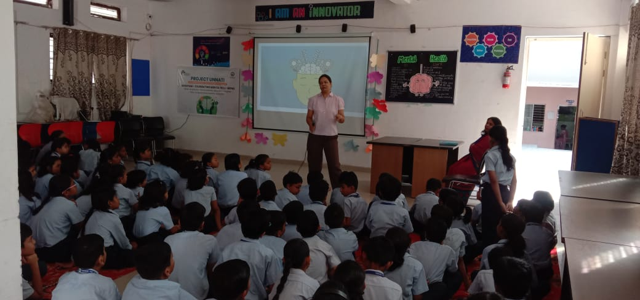

Activity 4: Poster Making on Gender Equity (Week 2, Day 9)
Classes - VI & VII
To encourage students to express their views on gender equity, fostering awareness, discussion, and advocacy for a more equitable and inclusive society. Art can be a powerful medium for self-expression and dialogue on social concerns.
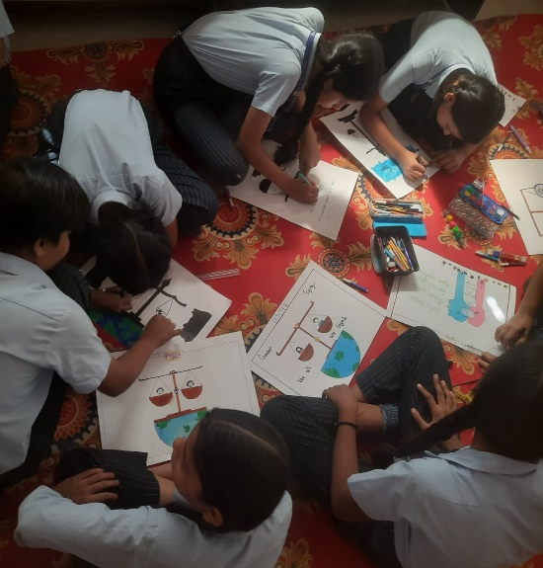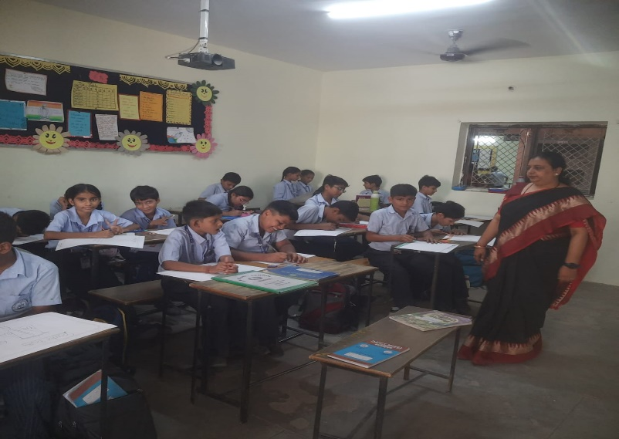

Activity 5: Group Discussion on Effect of social media on Mental Well-being (Week 2, Day 10)
Classes - IX to XI
To explore the impact of social media on mental well-being, foster critical thinking and equip participants with strategies to use social media in ways that support their mental health and well-being. It helps ton increase awareness of social media's impact, improved digital literacy, and the development of healthier online habits for enhanced mental well-being.
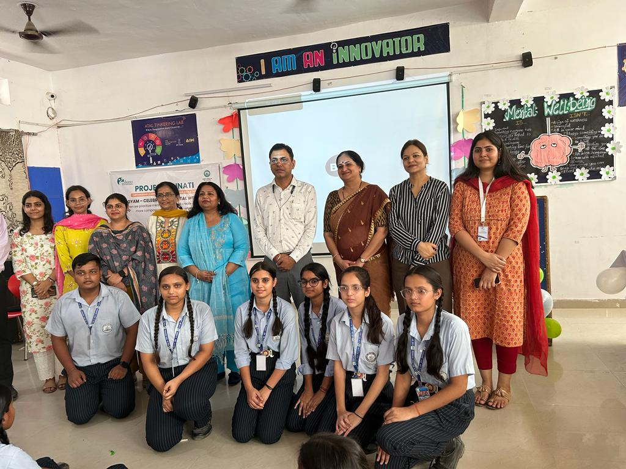

Activity 6: Role play (Week 3, Day 16)
Class - VIII
The activity aims to engage students in interactive role-play to foster awareness about bullying, gender role equity and informed and responsible cyber use, encouraging a proactive approach to these issues. Students develop the effectiveness of role-play as a tool for an active learning, emphasizing problem-solving and practical skill development, thus enhancing student’s ability to address real-life situations
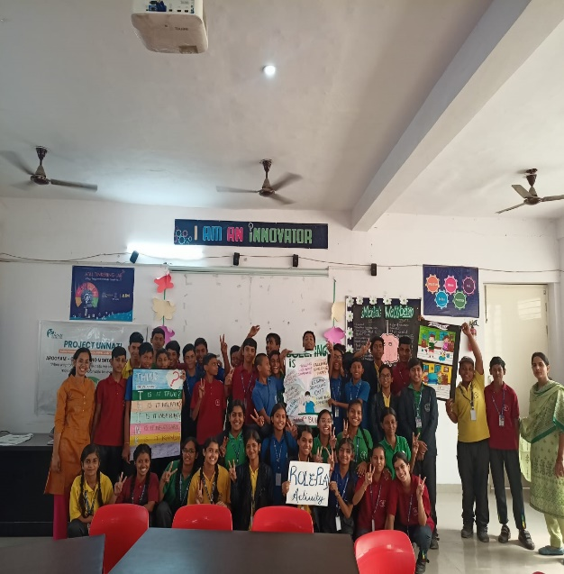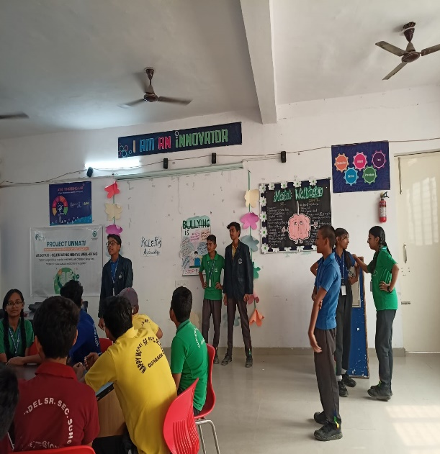

Arogyam 2023 programme (Mental Health Awareness Week celebration) was successfully celebrated by H M SR. SEC. SCHOOL with a wide range of activities that engaged both students and teachers. By addressing various aspects of mental health, safe touch, gender equity and social media use, the event achieved its goals of raising awareness and promoting positive discussions. Students enjoyed and learned from these various activities.

